Diamond Cutter Translation Tool — daily digest, Thursday 10 September 2026
Headline. Almost everything below came from using the tool rather than from planning to build it. I hovered over a button and nothing appeared; I opened a pane and could not find the way in; I pasted a verse and it refused the whole thing over a character I could not see; I ran a drill and the English was five times longer than the Tibetan. Each one turned out to have a cause worth finding, and several of them were hiding something larger than the symptom.
Two things also arrived that I have wanted for a while. The Sanskrit workbench now reads a mantra written in Tibetan letters and gives back how to say it — which is the everyday problem in the more esoteric texts. And the drills and the trainer now run as an app on my phone.
Then the afternoon turned into something I did not expect. We now hold three thousand recordings of Tibetan syllables spoken by native speakers, and the tool can find the right one for nineteen out of twenty syllables in our texts. It could not this morning — my first attempt was wrong in a way worth writing down.
Everything is tested. 115 automated suites green, the self-check at zero failures, and the engine batteries unchanged.

What I did

Every button now tells you what it is
I hovered over the Library button and got nothing. The pane buttons carried no description at all, and twenty-eight of the ribbon buttons carried only their own name. Both answer the same way now: the name, then a sentence saying what it is for — fourteen of them lifted word for word from the manual, so the two cannot drift apart.

Day now means Day
I had Day selected and dark chrome on screen, and both were behaving as written: the old switch only ever set an appearance when Night was on, so with it off the Mac decided. Appearance is three ways now — Day, Night, Match system — and Match system is the answer to whether night can arrive on its own.
The missing labels under the icons were never missing; they were invisible. The same fault made the shading uneven: twenty-five places across eight panes had a colour written into the text of the style itself, and a written-in colour cannot follow anything.

The Draft workspace shows you the way in
I said plainly that I did not understand how to use it. There was no Load source button anywhere on screen, and three gold headings introduced nothing at all. The headings are gone, and the pane carries its own way in.

The dictionary comes out as a spreadsheet
The dictionary drawn from the alignment of my courses now exports as CSV every time it is rebuilt — 20,933 rows over 10,758 headwords, courses one through five — with every piece of metadata we hold, and its provenance carried in each row so a spreadsheet separated from its covering note still says what it is. Three more files alongside it: English to Tibetan, each course’s own glossary, and a change report so nobody has to re-read twenty thousand rows.
Two faults surfaced in the building. The ACIP column had been empty for every entry of the published page, because the index is stored one way round and was being read the other. And a handful of headwords are English front matter rather than Tibetan, which is harmless as text and becomes fabrication the moment a Tibetan column is computed from it.

Sanskrit, and mantras
I pasted a verse of Nagarjuna and four of six rows showed a warning triangle with nothing beside it. The refusal was right — this engine never guesses — but it would not say what it could not read. It does now.
The cause was worse than the symptom: the converter knew only five whitespace characters, so a non-breaking space, which is exactly what a word processor puts on the clipboard, made it refuse an entire passage.
Then the part I am most pleased with. The mantras in the more esoteric texts are not Tibetan at all — they are Sanskrit written in Tibetan letters. The tool now takes that script and gives back how it is recited.
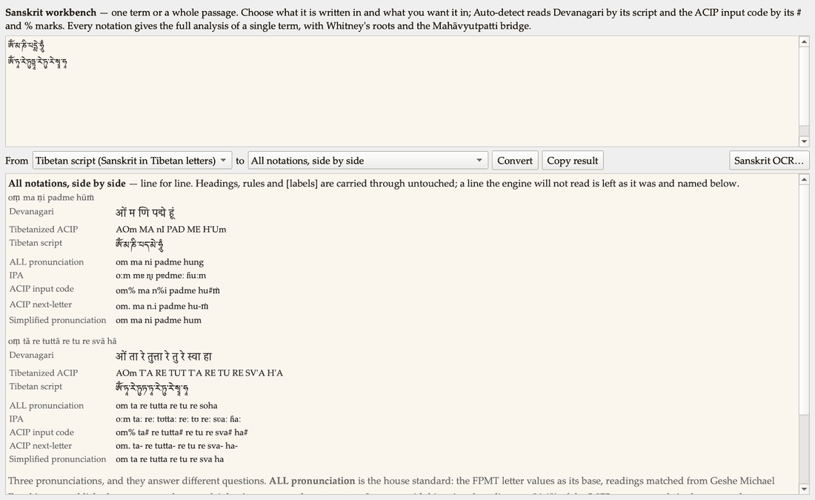
Two mantras entered as Tibetan script, read back in every notation.
There is now an ALL Sanskrit pronunciation standard: the FPMT letter values as its base, readings matched from my own published courses over them, and my own amendments on top. It agrees with my printed readings on 94.4% of the 5,875 mantra words in the corpus that carry both the code and my reading.

The drills
Seven screenshots of drills that looked wrong turned out to be four faults.
The English did not match the Tibetan in size: the drill picks one clause but printed my English for the whole segment, and measured over three hundred drills the clause averaged 27.5% of the segment above it. Raw source code was leaking into the Tibetan. And title lines were being drilled as sentences far more often than chance — the adaptive draw prefers short segments and the title catalogue is the shortest material we have, so twenty to twenty-five percent of my drills were catalogue entries.
The one I am most pleased to have caught myself: an option beginning with an open parenthesis against a segment ending in a closing one. The punctuation was telling the learner the answer before they read a word of Tibetan.
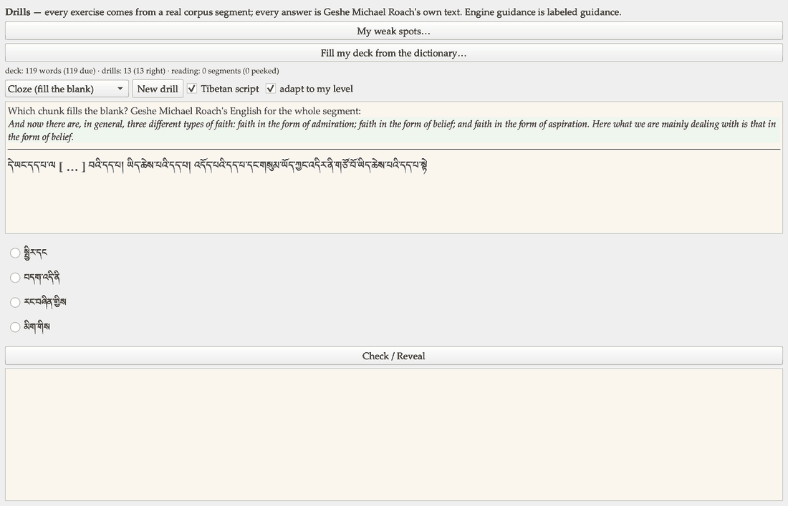
A drill as it now stands: the whole segment, English in proportion, no source code, no tell.
I also said the English still often looked too long to be the equivalent. It was, and the reason is exact: my own example measures 4.3 English words per Tibetan word counting the bracketed material and 1.4 without — 1.4 being the corpus median exactly. The brackets are things I supplied as translator. They are greyed and labelled as supplied now.

On my phone
The drills and the trainer now run as an iPhone app. The whole core compiled for a real device unchanged — seventy-eight files, no edits.
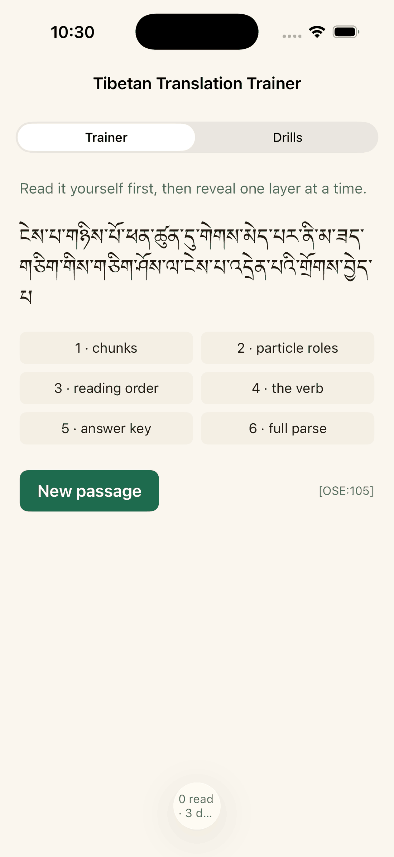
The Trainer on iPhone: read the passage, then reveal one layer at a time.
Seeing it on a small screen immediately exposed what the desktop had hidden: one segment pairs 5,180 English words with five Tibetan words.

A Tibetan voice for the whole dictionary
Years ago a Tokyo cultural centre called Kawachen built a small teaching app: you tap the letters of a Tibetan syllable one by one and hear a native speaker say each piece, and then the syllable whole. I was in touch with them some time ago and they gave me permission to use their recordings. Today we brought them in.
There are 3,002 of them — every combination of root letter, vowel and ending that Tibetan allows, plus the spoken names of every mark: gi gu, ya btags, ga sngon jug, the words a Tibetan teacher says aloud while spelling. No two recordings are alike; twenty-two megabytes of a human voice.
The useful question was not how many we had but how far they reach. They speak 96.5% of every syllable in our forty-two thousand aligned segments faithfully — two thirds from that syllable’s own recording, and most of the rest by dropping a letter Tibetan writes but does not say. A further 1.3% are marked as approximate, and 2.2% we simply cannot say and label as such.
Getting them was not a download. The site is a machine that assembles a syllable as you tap, and its file names are numbers that mean nothing on their own. Rather than guess, I drove the thing button by button until it told me what each number meant. That turned out to be worth more than the audio.
Their numbering is a map of how Tibetan is actually pronounced. It files recordings by sound, not by spelling — so five different spellings that are all simply la share one recording, and a superscript that raises a letter’s tone earns a number of its own. That is an independent account of the reading rules, written by Tibetan teachers with no connection to the conventions our own engine follows. We have never had a second opinion on that engine. Now we do, and it agrees: eleven of twelve cases where they merge, three of three where they fold one spelling onto another, and all nine tone cases behave exactly as our engine intends.
The one disagreement is ours to keep. They treat three spellings as one sound where we separate them; my own published pronunciations settle it, with over four hundred attested readings on one and two hundred and twenty-nine on the other. Our engine is right for our convention, and I filed the reasoning rather than silently changing anything.

The mistake I made, and how it was caught
My first attempt today was wrong, and I would rather report it than quietly fix it.
I matched each syllable to a recording using our own pronunciation engine — which seemed obviously right, since that engine is the authority on how our texts are read. It is not right for sound. Our written convention deliberately flattens distinctions that the ear does not: it prints ཀ and ཁ both as ka, ས and ཟ both as sa, because that is the simplification an English reader needs. The recordings make no such simplification — those are four different sounds, recorded separately by four openings of a mouth.
So the tool was matching by the flattened spelling. Seventy-one per cent of syllables were being given another syllable’s recording, and eighteen hundred of our three thousand recordings could never be reached at all. Worse, every one of those substitutions was labelled as an exact match. It would have taught a beginner that ཁ sounds like ཀ — the precise distinction they are there to learn.
The fix was to match on the spelling itself, which is what the recordings are actually filed under. Everything then had to be re-measured, which is where the honest 96.5% above comes from; the 99.3% I would have reported this morning was counting matches that were wrong.
What I want to note is how it surfaced. It was not a crash and no test failed — my test proved the new code agreed with the code it was copied from, and both were wrong in the same way. It was found by asking a wider question than “does this work”: by setting several independent readers on the problem of what this asset is actually good for, and one of them checked the matching rather than trusting it. That is the second time this week that stepping back has been worth more than pressing on.

What it will and will not do
I want to be plain about this, because it would be easy to oversell.
Each recording is one syllable spoken on its own, about half a second. Playing them in a row gives reading aloud, syllable by syllable, in a real human voice. It does not give a native speaker reading a sentence — real speech has a rise and fall across a whole phrase that separate syllables cannot supply. That is not a disappointment: reading a text out syllable by syllable is exactly how Tibetan has always been taught. But the tool will say which it is doing, and will never dress one up as the other.

Two versions of the tool from here
The recordings are ours to use, not ours to give away. So the tool now builds two ways from one set of sources: the version on my desk, which can speak, and the version we release, which cannot — and in the public one the speaking parts are not merely switched off, they are not built at all. A released copy could not reach a recording even if someone put the files beside it. I would rather that be a fact about the build than a promise in a document.
Both were tested today, and the same test suite passes in one and correctly stands down in the other.

Decisions I made along the way
My title goes with my name. Everywhere — prose, the interface, email, document titles and file names. I also retired the internal abbreviation we had been using, which stands for a form of address only close students use. The dictionary is the Geshe Michael Roach Dictionary.
TestFlight before the App Store. The app goes to our team and to the students who want it, not to a public store — because every alignment in it is machine-matched and awaiting Geshe Michael Roach’s ruling, and the App Store audience is the public.
A wrong glyph is worse than an honest flag. One conversion I could have shipped renders a syllable incorrectly rather than not at all. It stays flagged.
The recordings stay in house. Kawachen gave permission to use them, which is not permission to hand them on. They will not go into the phone app either, because sending a build to students is giving them away. If we want that, we ask Kawachen first.
Digests are centred from now on — headers and figures. Body prose stays left, because a centred paragraph is harder to read.

Numbers
Automated suites, all green | 115
Self-check failures | 0
Panes and buttons that now describe themselves | 24 and 121
Dictionary rows exported | 20,933 over 10,758 headwords
ALL pronunciation standard, agreement with my printed readings | 94.4%
Drills that were catalogue entries, before and after | 20–25% → 0%
Unreadable syllables in a drill pack, yesterday → now | 45% → 14%
Core files compiling for iPhone unchanged | 78 of 78
Tibetan syllable recordings now held | 3,002 (all distinct, 22.3 MB)
Syllables mismatched by my first attempt, then fixed | 71%
Share of our corpus spoken faithfully | 96.5% (1.3% approximate, 2.2% not held)
Their reading rules vs our engine | agrees on 11 of 12, 3 of 3, 9 of 9
Syllables proving the new code against its original | 11,939, exactly

Open questions for leadership
The dictionary’s accuracy method. I asked whether we should run the AI alignment twice and reconcile the two, the way we double-key a text into a, b, c, d and e files. The honest answer is that the analogy breaks: a typo is random, but an alignment error is a misunderstanding, and a misunderstanding is exactly the thing that repeats. Two runs of the same model are one sample twice. The recommendation is to attack what we have already called correct — ninety-one of a hundred audited items were called sound by one reader and never challenged — before buying a second pass over forty thousand pages.
The tier. Everything in the dictionary and in the phone app is machine-matched and unreviewed. It stays that way until Geshe Michael Roach rules. What I would like to know is the shape he wants for ruling on it; a review queue with a column for his decisions is easy to produce.

Next
Put the voice where it belongs: highlight any Tibetan, right-click, hear it read. Then rebuild Kawachen’s own teaching screens inside the tool — the syllable builder, the roster you can play back, and the listening quiz — so the whole of it works with no internet. Then get the app onto phones through TestFlight, and the first three things from the Learn plan: a first rung for someone who has never seen the script, a vocabulary surface that draws on the corpus instead of context-free cards, and a loop that turns a diagnosed weakness into the next exercise.

